

MASTER OF SCIENCE IN MANAGEMENT AND SYSTEMS
Research Process and Methodology
MEMORANDUM

TO: Dr. Nicole Zeidan
FROM: Parithi E (El)
DATE: 12/05/24

RE: The Impact of AI-Generated Content on Millennial Perception of Brand Authenticity: Balancing Efficiency and Trust in Digital Marketing

Chapter 1 – Introduction

Background
Digital marketing is evolving rapidly with the integration of artificial intelligence (AI), offering new tools for businesses to enhance customer engagement. AI-generated content, particularly on social media, has the potential to improve customer interactions by personalizing experiences. AI-generated content on social media platforms allows companies to offer personalized and scalable marketing strategies, which are key to improving consumer engagement and loyalty (Dwivedi et al., 2021). Millennials, who are a key demographic in the U.S. market, value authenticity in brand communications, making it critical for businesses to balance AI’s efficiency with genuine engagement. Artificial intelligence (AI) is currently having a dramatic impact on marketing (Bock et al., 2020). Understanding how AI-generated content impacts millennials’ perception of brand authenticity is crucial for optimizing marketing strategies in this fast-paced digital landscape.

Problem Definition
The use of AI-generated content in marketing raises concerns about maintaining brand authenticity, especially among millennials (Bock et al., 2020). This group is known for its preference for authentic and relatable content, which presents a challenge for businesses relying on AI to scale their social media efforts. While AI-generated content offers significant benefits such as scalability, personalization, and efficiency, it can also raise concerns about the authenticity of brand communications (Meire et al., 2019). If businesses cannot align AI-generated content with the values and expectations of millennials, they risk damaging trust and engagement. Therefore, it is essential to explore how AI-generated content affects the perception of authenticity in millennial consumers.

Problem Statement
The problem this study addresses is that AI-generated content may reduce the perception of brand authenticity among millennial consumers, which could negatively impact engagement and brand loyalty.

Purpose of the Study
The purpose of this study is to investigate the effect of AI-generated social media content on millennial consumers’ perception of brand authenticity in the U.S. market. The study will explore whether AI-generated content can maintain or enhance the perception of authenticity, which is critical to building trust and driving engagement among millennials.

Research Questions

The study will attempt to answer the following research questions.
- What effect does AI-generated social media content have on millennial consumers' perception of brand authenticity compared to traditional content?
- How do millennials differentiate between AI-generated and human-generated content in terms of trustworthiness and authenticity?

Significance of the Study
The overall significance of this study is to provide businesses with valuable insights into how AI-generated content can impact consumer trust and engagement. By addressing the specific needs and preferences of millennials, this study aims to help businesses optimize their digital marketing strategies to ensure they maintain authenticity while leveraging the benefits of AI (Dwivedi et al., 2021). Understanding these dynamics will help companies optimize their digital marketing strategies while maintaining authenticity (Van Noot et al., 2020). Marketing professionals, content creators, and business leaders will benefit from this research by understanding how to better align AI-driven strategies with consumer expectations.

Chapter 2 – Literature Review Draft

Introduction
The rapid advancements in artificial intelligence (AI) have significantly influenced the field of digital marketing, providing businesses with tools to enhance efficiency, scalability, and personalization. Social media platforms have become a key area for implementing AI technologies, allowing brands to engage with consumers in innovative ways. However, with AI-generated content on the rise, questions around its impact on consumer trust and brand authenticity have emerged. This study focuses on understanding how AI-generated content affects millennial consumers' perception of brand authenticity and explores the factors that influence this relationship.

Industry
The digital marketing industry is evolving rapidly, with AI adoption playing a pivotal role in shaping strategies. According to research by Dwivedi et al., 2023, the integration of AI in marketing has grown due to its ability to analyze vast amounts of consumer data and create tailored content. In the social media domain, platforms like Instagram and Facebook have enabled brands to leverage AI for personalized advertising campaigns. Millennials, who dominate these platforms, are particularly sensitive to the authenticity of brand communications, making this demographic a crucial focus for AI-driven strategies. The marketing industry must address the balance between leveraging AI efficiency and maintaining trust, which is central to long-term consumer relationships.

The Problem
While AI-generated content offers numerous benefits, it also raises concerns about trust and authenticity. Research suggests that millennials highly value genuine and relatable brand communications. AI-generated content, if not transparently disclosed, can risk being perceived as manipulative or insincere, leading to a decline in trust and engagement. For example, Meire et al., 2019, highlight that consumers often struggle to differentiate between AI-generated and human-generated content, creating skepticism about the intent behind such marketing efforts. This presents a challenge for brands aiming to maintain authenticity while embracing AI technologies.

Proposed Solution
The study proposes a framework that incorporates transparency in AI-generated content as a mediating factor to improve millennials' perception of brand authenticity. By clearly disclosing the use of AI in content creation, brands can align with millennials' expectations for ethical and honest communication. Furthermore, understanding the type of product or service being marketed is essential, as high-involvement products may require a more humanized approach, while low-involvement goods can benefit from AI-driven personalization. This approach aims to balance the efficiency of AI technologies with the authenticity required to maintain consumer trust.

The Technology
AI technologies in marketing, particularly generative AI models like OpenAI's GPT or DALL·E, have revolutionized content creation by automating processes such as text generation, image creation, and audience targeting. These models leverage machine learning algorithms to analyze consumer data and create personalized content. However, their application in social media marketing requires careful consideration of transparency, as the "black-box" nature of AI systems can make their operations opaque to consumers. This study emphasizes the role of transparent disclosures and personalization techniques in enhancing consumer acceptance of AI-generated content.

Use Cases
- Personalized Marketing Campaigns: AI-generated content is widely used in designing personalized ads tailored to consumer preferences, improving click-through rates and engagement.
- Chatbot Interactions: Many brands use AI-driven chatbots to provide instant customer support while maintaining a conversational tone.
- Content Recommendation: AI algorithms analyze user behavior to suggest relevant content, such as video recommendations on YouTube or targeted ads on Instagram.
- E-commerce Personalization: AI-generated product descriptions and email campaigns help e-commerce brands scale their marketing efforts without compromising relevance.
These use cases highlight the versatility of AI technologies in digital marketing, showcasing their potential to enhance engagement while also posing challenges to authenticity.

Conclusion
AI-generated content has immense potential to transform digital marketing by enabling brands to engage with consumers more effectively. However, for millennials, the perception of brand authenticity remains a critical factor influencing trust and loyalty. This study aims to bridge the gap by exploring how transparency and personalization can mitigate the risks associated with AI-generated content. By addressing these challenges, brands can leverage AI technologies to create meaningful and authentic connections with their audience.

Definition of Terms
- AI-Generated Content: Content created by artificial intelligence algorithms, including text, images, and videos, for digital marketing purposes.
- Brand Authenticity: The perception of a brand's genuineness, trustworthiness, and alignment with its stated values.
- Transparency: The practice of disclosing AI involvement in content creation to foster trust and reduce consumer skepticism.
- Millennials: Individuals born between 1981 and 1996, representing a key demographic for social media marketing.
- Engagement Metrics: Quantitative measures of consumer interaction with content, such as likes, shares, comments, and click-through rates.

Chapter 3 – Research Design and Methodology

Theory
The theory underlying this research focuses on the intersection of artificial intelligence, consumer behavior, and digital marketing. AI-generated content on social media has revolutionized how brands interact with consumers by enabling personalized and scalable communication strategies. The personalization afforded by AI can make content more engaging and relevant to target demographics, such as millennials. However, the introduction of AI into content creation poses potential risks to brand authenticity, a key factor influencing millennial purchasing behavior. Authenticity, defined as the perception of genuineness and relatability in brand communications, is highly valued by millennials, who are skeptical of overly automated or insincere messaging. Research suggests that while AI-driven content can optimize efficiency, it can also undermine trust if consumers perceive the content as impersonal or manipulative. Thus, the relationship between AI-generated content and brand authenticity is complex and influenced by various mediating and moderating factors.
Specifically, this study examines how transparency about AI usage mediates the impact of AI-generated content on brand authenticity (Dwivedi, 2004). Transparency, such as disclosing AI involvement in creating social media posts, is hypothesized to enhance trust by aligning with millennial preferences for ethical and honest communication. Additionally, the type of product or service being marketed serves as a key mediator, as some industries (e.g., technology or low-involvement consumer goods) may be more suited to AI-generated content than others (e.g., luxury or high-involvement products). Moderating variables, including demographic factors, prior exposure to AI-generated content, and existing brand loyalty, further shape consumer responses. For instance, consumers familiar with AI technologies may view AI-generated content more favorably, while those with strong brand loyalty might be more forgiving of perceived inauthenticity. This theoretical framework provides a foundation for exploring the nuanced relationship between AI-generated content, authenticity, and engagement in the context of social media marketing.

Research Objective and Research Question
Research Objective: To evaluate the effect of AI-generated social media content on millennial consumers' perception of brand authenticity and to identify the factors that mediate or moderate this relationship.
Research Question: What effect does AI-generated social media content have on millennial consumers' perception of brand authenticity in the U.S. market?
Theoretical Framework
The following framework illustrates the relationships between the independent, dependent, moderating, mediating, and outcome variables.
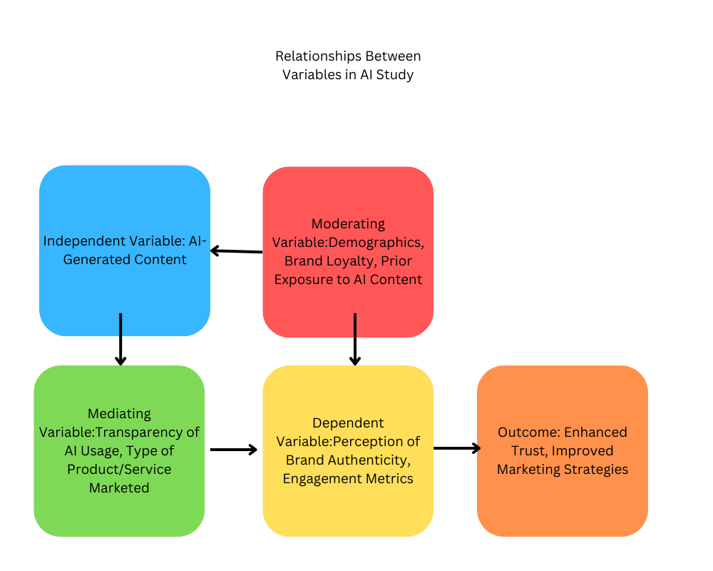
Variables
Independent Variable:
- AI-Generated Content- refers to social media posts and advertisements created using artificial intelligence tools. This variable captures the role of AI in producing personalized and scalable marketing materials. It includes variations such as whether the AI involvement is disclosed and the specific characteristics of the content, such as tone, personalization, and relevance. These aspects are critical to understanding how AI-generated content influences consumer perception, particularly among millennials who value authenticity and trust in brand interactions.

Dependent Variable:
- Perception of Brand Authenticity - Brand authenticity refers to the extent to which consumers perceive a brand’s communication as genuine, relatable, and trustworthy. For millennials, authenticity is a critical factor in fostering loyalty and engagement with a brand. This study measures brand authenticity using surveys that assess consumer perceptions of AI-generated content, focusing on whether it feels credible and aligned with the brand’s identity. By examining how AI-generated content influences this perception, the study aims to determine whether such content can maintain or enhance the sense of authenticity that is essential for millennial engagement.
- Engagement Metrics - Engagement metrics capture consumer interactions with social media content, such as likes, shares, comments, and click-through rates. These metrics provide a quantitative measure of consumer interest and involvement with AI-generated content. High engagement often signals that the content is relevant and appealing to the audience. This study analyzes engagement metrics to assess whether AI-generated content drives higher levels of interaction compared to human-generated content, shedding light on its effectiveness in creating meaningful consumer connections.

Moderating Variables:
- Demographic data (survey questions about age, gender, income).
- Brand loyalty (measured through historical engagement with the brand).
- Prior exposure (survey questions on familiarity with AI-generated content).
Mediating Variables:
- Transparency of AI usage (survey responses on whether consumers were aware of AI involvement).
- Type of product or service (survey responses identifying perceived suitability of AI for different products).
Descriptive Variables:
- Platform Type:
  - Social media platforms like Instagram, Facebook, or Twitter, as engagement trends may vary by platform.
- Content Format:
  - Format of AI-generated content, such as images, videos, or text, which could impact consumer responses.
- Posting Frequency:
  - Number of posts per day or week, influencing consumer familiarity and saturation with the brand’s AI content.
Data Collection
Overview of Data to Be Collected
This study will collect data from social media platforms, surveys, and engagement analytics to evaluate how AI-generated content impacts millennial consumers’ perception of brand authenticity. Data will include consumer feedback on brand authenticity, engagement metrics, and other variables such as demographics, transparency, and content attributes. The data will be sourced from platforms where AI-generated content is actively used, such as Instagram, Facebook, and Twitter.
Independent Variable
AI-Generated Content:
- Definition: Social media content created using AI, varying in disclosure and personalization levels.
- Data Source: Social media platforms (Instagram, Facebook, Twitter).
- Measurement:
  - Type and characteristics of AI-generated content (e.g., tone, personalization).
  - Collected from platform APIs or brand case studies.

Dependent Variable
Perception of Brand Authenticity:
- Definition: Consumer evaluations of trust, genuineness, and relatability.
- Data Source: Surveys distributed to millennials (aged 25–40).
- Measurement: Likert-scale survey ratings assessing trust, credibility, and alignment with brand identity.
Engagement Metrics:
- Definition: Quantitative measures of consumer interactions with content.
- Data Source: Social media analytics from platform APIs.
- Measurement: Likes, shares, comments, and click-through rates for AI-generated posts.
Moderating Variables
Demographics (Age, Gender, Income):
- Data Source: Self-reported data from survey participants.
- Measurement: Survey questions collecting demographic details.
Brand Loyalty:
- Data Source: Survey questions measuring past interactions or purchase history.
- Measurement: Historical engagement data and self-reported loyalty scores.
Prior Exposure to AI-Generated Content:
- Data Source: Survey responses assessing familiarity with AI content.
- Measurement: Likert-scale responses (e.g., "Never encountered" to "Frequently encountered").
Mediating Variables
Transparency of AI Usage:
- Definition: Whether the content explicitly discloses AI involvement.
- Data Source: Survey questions evaluating consumer awareness and reactions to disclosure.
- Measurement: Consumer responses to AI-disclosed versus non-disclosed content.
Type of Product or Service Marketed:
- Definition: Product categories associated with the AI-generated content.
- Data Source: Survey and content analysis.
- Measurement: Categorical classification (e.g., high-involvement vs. low-involvement products).
Descriptive Variables
Platform Type:
- Definition: Social media platforms used for AI-generated content.
- Data Source: API data from Instagram, Facebook, and Twitter.
- Measurement: Categorical variable (e.g., Instagram = 1, Facebook = 2).
Content Format:
- Definition: Type of AI-generated content (e.g., images, videos, or text).
- Data Source: Content analysis of social media posts.
- Measurement: Categorical classification based on format.
Posting Frequency:
- Definition: Number of posts published within a specific timeframe.
- Data Source: Platform analytics or API data.
- Measurement: Numeric count of posts per day or week.
Sample Size
Survey Participants: 300 millennials across diverse demographics.
Social Media Data: Engagement data for 100 posts, split between AI-generated and human-generated content.
Data Analysis
Descriptive Statistics
To provide a comprehensive understanding of the data, descriptive statistics will summarize the main variables. This will include measures such as means, standard deviations, ranges, and medians for both independent and dependent variables, as well as moderating and mediating variables. Key elements:
- AI-Generated Content: Descriptive statistics will include frequency distributions for content types (e.g., personalized vs. generic), transparency disclosures, and platform usage.
- Brand Authenticity Perception: Likert-scale ratings will be summarized to assess central tendencies and variability in trust, genuineness, and relatability.
- Engagement Metrics: Summaries for likes, shares, comments, and click-through rates will provide a baseline for content performance.
Visualizations: Histograms, boxplots, and scatterplots will be used to illustrate distributions and relationships between key variables.
Correlation Analysis
To explore the relationships between variables, a correlation matrix will assess the strength and direction of linear relationships. This includes:
- Correlations between AI-Generated Content and Brand Authenticity Perception.
- Correlations between Transparency (mediating variable) and authenticity ratings
Pearson’s Correlation Coefficients (r-values) will indicate the strength and direction of relationships.
Testing Hypotheses
To validate hypotheses, statistical tests will be performed with a significance level of p < .05:
- T-Tests:
  - Compare brand authenticity ratings for AI-disclosed vs. non-disclosed content.
  - Example: Do consumers perceive disclosed AI content as more trustworthy?
- ANOVA (Analysis of Variance):
  - Evaluate differences in engagement metrics (likes, shares) across transparency levels or product types.
  - Example: Does AI transparency significantly influence engagement?
- Chi-Square Tests:
  - Assess independence between transparency disclosure and consumer trust.
  - Example: Is there a significant association between transparency levels and positive sentiment?

Regression Analysis:
A regression model will quantify the relationship between AI-generated content and brand authenticity while controlling for mediating and moderating variables:
- Model:
Brand Authenticity = β0 + β1(AI Content) + β2(Transparency) + β3(Demographics) + ε
- Outputs:
  - Standardized Coefficients (β): Strength and direction of relationships.
  - Adjusted R²: Explanatory power of the model.
  - P-values: Statistical significance of predictors.

Limitations
- Survey Bias: Responses may not fully capture authentic perceptions due to social desirability bias.
- Sample Representativeness: Findings may not generalize to non-millennial demographics or international markets.
- Platform-Specific Trends: Engagement metrics may vary significantly across different social media platforms.

Summary
This study proposes a detailed research design to evaluate how AI-generated social media content influences millennial consumers’ perception of brand authenticity and their engagement with brands in the U.S. market. The research examines the effects of AI transparency, personalization, and product type, while controlling for variables such as demographics, brand loyalty, and prior exposure to AI-generated content.

References
Dwivedi, Y. K., Ismagilova, E., Hughes, D. L., Carlson, J., Filieri, R., Jacobson, J., Jain, V., Karjaluoto, H., Kefi, H., Krishen, A. S., Kumar, V., Rahman, M. M., Raman, R., Rauschnabel, P. A., Rowley, J., Salo, J., Tran, G. A., & Wang, Y. (2021). Setting the future of digital and social media marketing research: Perspectives and research propositions. International Journal of Information Management, 59, 102168. https://doi.org/10.1016/j.ijinfomgt.2020.102168
Sohn, K., Sung, C. E., Koo, G., & Kwon, O. (2020). Artificial intelligence in the fashion industry: consumer responses to generative adversarial network (GAN) technology. International Journal of Retail & Distribution Management, 49(1), 61–80. https://doi.org/10.1108/ijrdm-03-2020-0091
Hollebeek, L. D., Menidjel, C., Sarstedt, M., Jansson, J., & Urbonavicius, S. (2024). Engaging consumers through artificially intelligent technologies: Systematic review, conceptual model, and further research. Psychology and Marketing, 41(4), 880–898. https://doi.org/10.1002/mar.21957
Bock, D. E., Wolter, J. S., & Ferrell, O. (2020). Artificial intelligence: disrupting what we know about services. Journal of Services Marketing, 34(3), 317–334. https://doi.org/10.1108/jsm-01-2019-0047
Ananthakrishnan, R., & Arunachalam, T. (2022). Comparison of consumers perception between human generated and AI aided brand content. Webology, 19(2), 6293. https://www.webology.org/data-cms/articles/20220324051907pmwebology%2019%20%282%29%20-%20458%20pdf.pdf

